Cashflow Forecast Template
(Print)

Print-off this template and fill it out to create your business cashflow forecast.
For an editable template, download our Microsoft Excel template, ‘Cashflow Forecast Template (Excel)’

Here is an example of a Cashflow forecast:

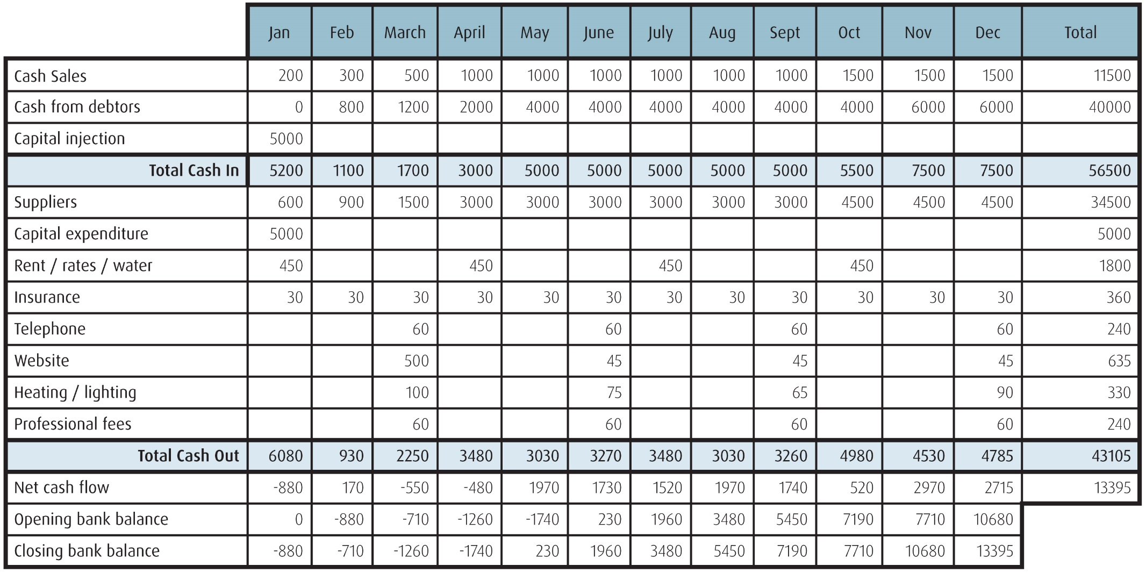

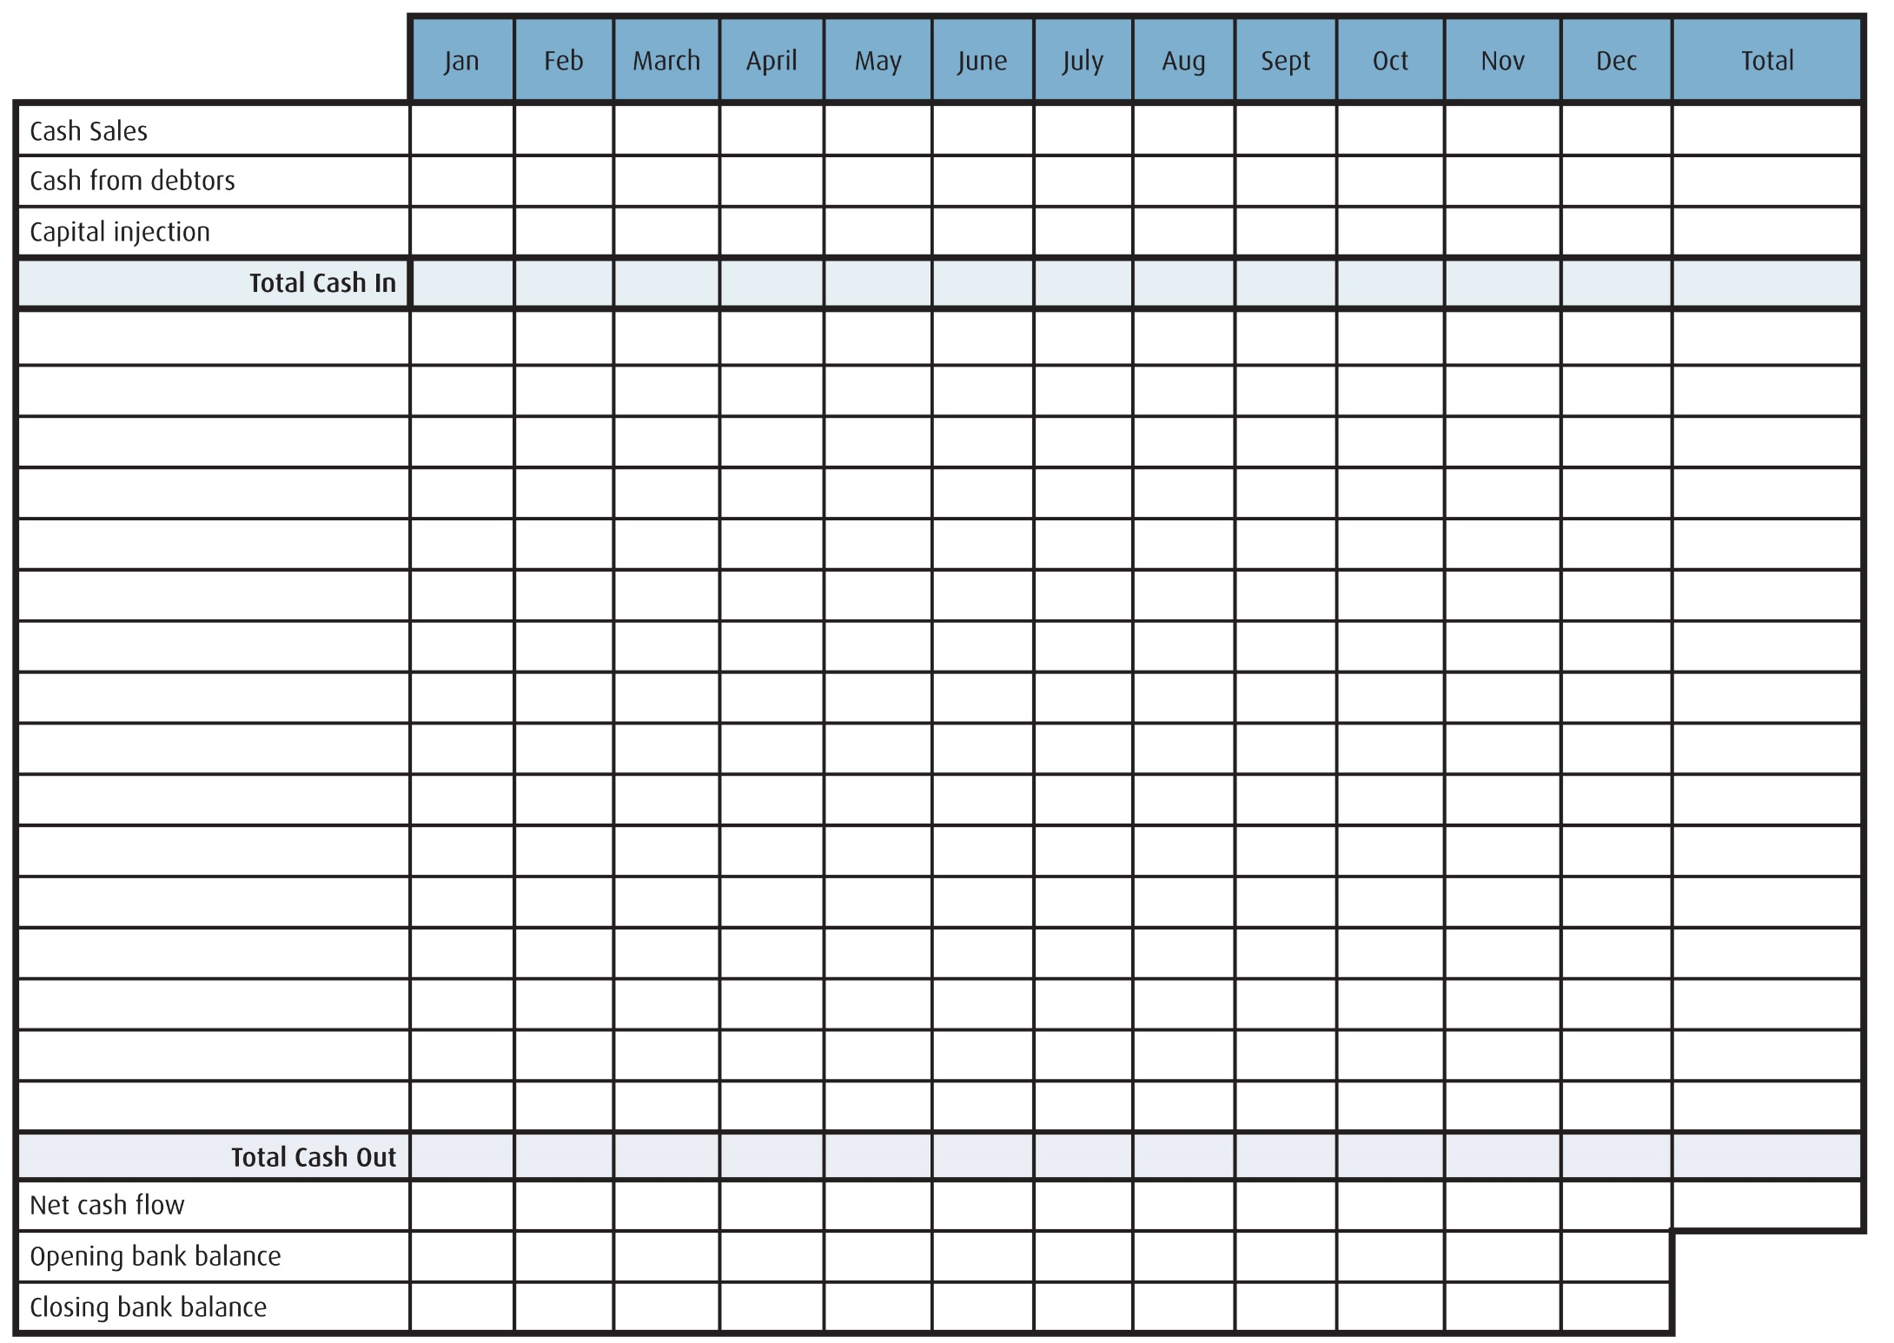
Now try your own:

