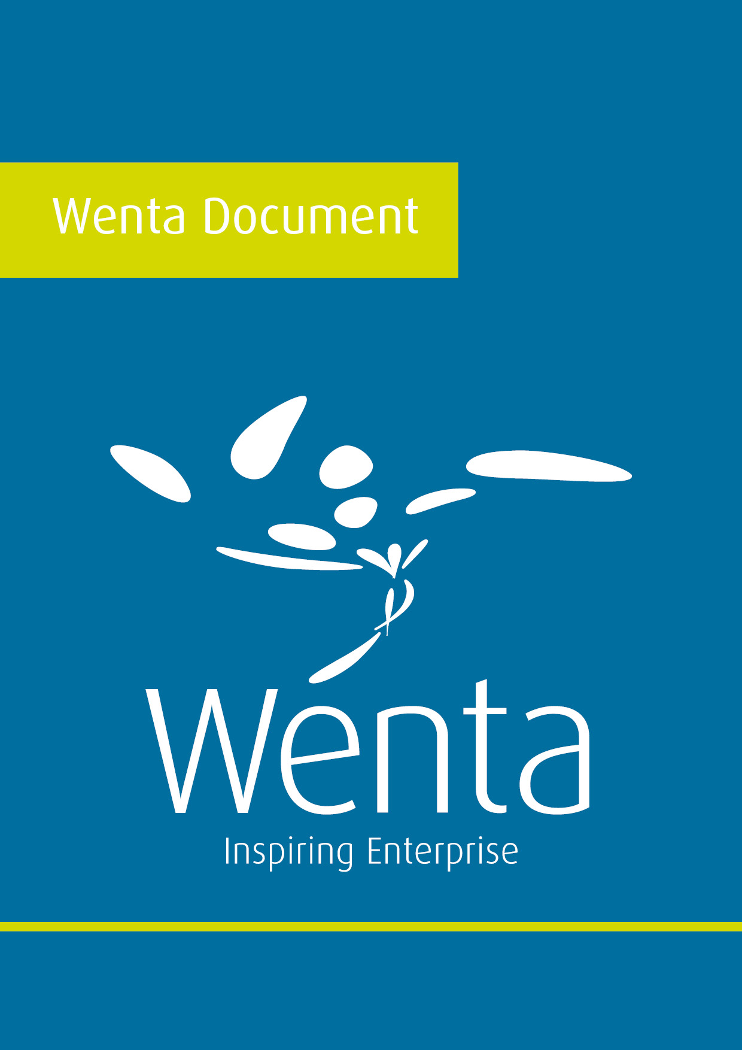

Sole trader, partnership and Limited Company –
The Benefits and Drawbacks
Every business must have a legal structure. We’ve set out a few of the benefits and drawbacks of some of the most common legal structures to help you consider which might be most appropriate for you.
Legal structure | Benefits | Drawbacks
Sole trader | Complete control Simple to set up and account for  Greater privacy  You take all rewards | Perceptions of unincorporated businesses  Credit rating/raising finance  Personal tax position
Partnership(s) | Greater level of expertise  Shared risks, responsibilities and workload  Simple to set up Greater privacy | Disputes of power Share of rewards Personal liability of all partners Perceptions of unincorporated businesses  Credit rating/raising finance  Personal tax position
Limited company | Limited personal liability  Prestigious, trusted status, professional appearance, positive image  Easier to sell the business - often seen as higher in value Can be easier to raise finance | Statutory requirements Information in the public domain  Likely to be more complex business (regulatory requirements), which will make the business more expensive and to run

